Strategy
(Behavioural)

Strategy design pattern is behavioral design pattern where we choose a specific implementation of algorithm or task in run time – out of multiple other implementations for same task.
The important point is that these implementations are interchangeable – based on task a implementation may be picked without disturbing the application workflow.
Strategy pattern enables a client code to choose from a family of related but different algorithms and gives it a simple way to choose any of the algorithm in runtime depending on the client context.
This pattern is based on Open/closed principle. We don’t need to modify the context [closed for modification], but can choose and add any implementation [open for extension].
For example, in Collections.sort() – we don’t need to change the sort method to achieve different sorting results. We can just supply different comparators in runtime.
In Strategy pattern, we first create an abstraction of algorithm. This is an interface having the abstract operation. Then we create implementations of this abstraction and these are called strategies.
A client will always call the abstraction, and will pass a context object. This context object will decide which strategy to use.

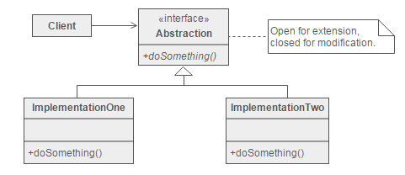

Real-World Analogy of Strategy Design Pattern
Imagine you’re planning a trip to a new city, and you have several options for getting there: by car, by train, or by plane. Each mode of transportation offers its own set of advantages and disadvantages, depending on factors such as cost, travel time, and convenience.

Strategy Design Pattern Example
Let’s consider a sorting application where we need to sort a list of integers. However, the sorting algorithm to be used may vary depending on factors such as the size of the list and the desired performance characteristics.
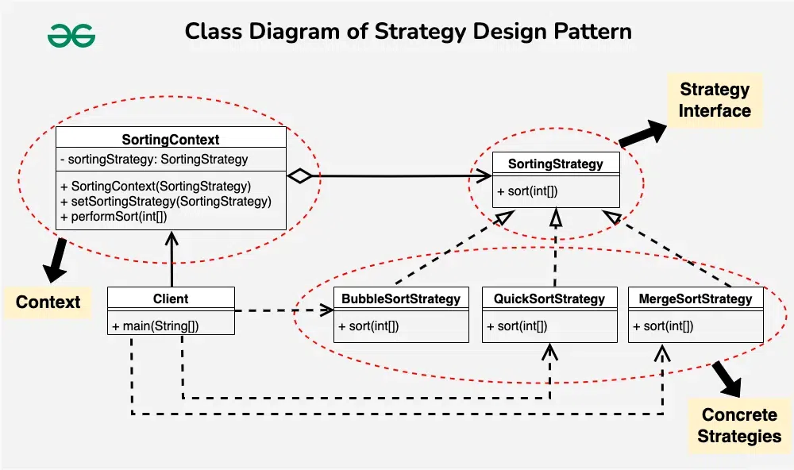

1. Context(SortingContext)
public class SortingContext {
private SortingStrategy sortingStrategy;

public SortingContext(SortingStrategy sortingStrategy) {
this.sortingStrategy = sortingStrategy;
}

public void setSortingStrategy(SortingStrategy sortingStrategy) {
this.sortingStrategy = sortingStrategy;
}

public void performSort(int[] array) {
sortingStrategy.sort(array);
}
}

2. Strategy Interface(SortingStrategy)
public interface SortingStrategy {
void sort(int[] array);
}

3. Concrete Strategies
// BubbleSortStrategy
public class BubbleSortStrategy implements SortingStrategy {
@Override
public void sort(int[] array) {
// Implement Bubble Sort algorithm
System.out.println("Sorting using Bubble Sort");
}
}

// MergeSortStrategy
public class MergeSortStrategy implements SortingStrategy {
@Override
public void sort(int[] array) {
// Implement Merge Sort algorithm
System.out.println("Sorting using Merge Sort");
}
}

// QuickSortStrategy
public class QuickSortStrategy implements SortingStrategy {
@Override
public void sort(int[] array) {
// Implement Quick Sort algorithm
System.out.println("Sorting using Quick Sort");
}
}

4. Client Component
public class Client {
public static void main(String[] args) {
// Create SortingContext with BubbleSortStrategy
SortingContext sortingContext = new SortingContext(new BubbleSortStrategy());
int[] array1 = {5, 2, 9, 1, 5};
sortingContext.performSort(array1); // Output: Sorting using Bubble Sort

// Change strategy to MergeSortStrategy
sortingContext.setSortingStrategy(new MergeSortStrategy());
int[] array2 = {8, 3, 7, 4, 2};
sortingContext.performSort(array2); // Output: Sorting using Merge Sort

// Change strategy to QuickSortStrategy
sortingContext.setSortingStrategy(new QuickSortStrategy());
int[] array3 = {6, 1, 3, 9, 5};
sortingContext.performSort(array3); // Output: Sorting using Quick Sort
}
}

5. Client Code
public class Client {
public static void main(String[] args) {
// Create SortingContext with BubbleSortStrategy
SortingContext sortingContext =
new SortingContext(new BubbleSortStrategy());
int[] array1 = {5, 2, 9, 1, 5};
sortingContext.performSort(array1);

// Change strategy to MergeSortStrategy
sortingContext.setSortingStrategy(new MergeSortStrategy());
int[] array2 = {8, 3, 7, 4, 2};
sortingContext.performSort(array2);

// Change strategy to QuickSortStrategy
sortingContext.setSortingStrategy(new QuickSortStrategy());
int[] array3 = {6, 1, 3, 9, 5};
sortingContext.performSort(array3);
}
}

Output:
Sorting using Bubble Sort
Sorting using Merge Sort
Sorting using Quick Sort
Resources:
https://howtodoinjava.com/design-patterns/behavioral/strategy-design-pattern/
https://www.geeksforgeeks.org/strategy-pattern-set-1/

